Welcome to the Everyday English Speaking Course!

This is my most popular course at Espresso English. More than 1000 students have taken it, and everyone says that it’s my most**practical and useful** course. So I’m glad you’re here, and I think you’re going to love this course.

Today I’m going to give you a few tips on how to get the most value out of the lessons so that you can improve your speaking as much as possible.

**1. CONVERSATION**

**Each lesson starts with a dialogue**, a conversation – there’s text and audio. And if you want an extra challenge, if you want to work on your listening, then try listening to the conversation in the audio without looking at the text and just try to understand as much as you can. Listening is a very important skill to develop.

I have another separate course focused on [listening](https://www.espressoenglish.net/do-you-want-to-improve-your-english-listening/), but you can also use this course to work on listening, too, by waiting to look at the text until after you’ve heard the conversation. So try that if you’d like a challenge, listen to the conversation once or twice without the text. Try to understand as much as you can, and then listen again with the text so that you can accompany every single word.

**2. EXPLANATION**

After the conversation, **I’ll explain and teach all the phrases** and expressions that you heard in the dialogue, and also give you more phrases for those particular situations. Now, if I were teaching you in a real life classroom, I would ask the class to repeat the phrases after me. So it’s good for you to do the same thing after every phrase. **Pause the audio and try to repeat it.**

It’s a really simple way to improve your pronunciation, improve the rhythm of your speaking and also get more confident about saving these phrases, right? Because if you can repeat them in the classroom, you’ll remember them better. And when it comes time to use them in real life, then it will be easier for you to say that phrase.

**3. QUIZ**

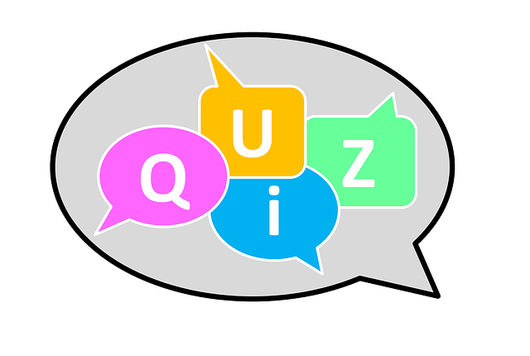In the final part of the lesson, you can put what you learned into practice.

First, there’s a **quiz**, where you’ll complete the phrases with the right word or expression. That’s just to review all the expressions and make sure you remember them correctly. The same way a native English speaker would say them.

**4. SPEAKING TASK**

The next activity is a **speaking task,** where I’ll give you a question or a few questions. You can record yourself speaking the answer, and then send in the audio. The Espresso English teaching team will correct it and evaluate it. We’ll give you some feedback on your grammar, vocabulary, pronunciation and anything else that can help improve your speaking.

Now you might be a little nervous to record yourself speaking, a lot of students are – they don’t want to do it. But I’m nervous recording video, actually, and I’m doing that right now. So you know, **with practice, it gets easier**. And it’s really important for you to practice speaking, and to get feedback, because that’s one of the most valuable parts of this course.

You might be wondering, about that speaking activity, if you should write out your answer in advance and just read it, or if you should speak spontaneously. Well, I want you to speak spontaneously, because that’s what we have to do in everyday life, right?

But if you’re nervous about doing that, then I suggest you write down only a few main points that you want to talk about. As you speak, look at your main points, but add more details while you’re talking. And then as you get more comfortable and confident with your English, try speaking more spontaneously. Just imagine that I’m sitting across the table or the desk from you, asking you the question, and reply just like you are speaking to me in real life.

So I hope you’ll take these tips to heart and put them into practice. I’m glad you’re here, and I’m excited to teach you phrases for everyday life. Go ahead and click on lesson 1 to begin!